Application Form

Maintenance Operative

Post Applied For:
All information supplied on this form will be treated as STRICTLY CONFIDENTIAL

1. Personal details
Surname |  |  |  |  | Forename (s)
Permanent Address and Postcode:

Address for correspondence (if different):

Telephone No(s) |  | Home: |  |  | Work:
Email Address |  |  |  |  | Mobile:
Are we able to contact you at work? |  |  |  | By Phone: Yes / No |  |  | By Email: Yes / No
Do you hold a current full car driving licence? |  |  |  |  |  | Yes / No

2. References
Please give details of two referees, one of whom should be your present or last employer. If you do not wish us to approach either of your referees without your permission place a cross in the box provided. Referees should not be related to you.

a) Present / Most Recent Employer |  | b) Second Referee
Name  Address |  | Name  Address
Position |  | Position
I do not wish my referee to be approached without my permission:

Reference a) Reference b)

3. Details of Education and relevant Training and Development

Dates | School/College/University/  Training Provider | Qualifications/Training Gained | Grade

4. Professional Qualifications, Membership of Professional Bodies

Dates | Full Details of Professional Qualifications, include level of membership, date achieved

5. Present/Most Recent Employment Details

Employer’s Name and Address |  | Job Title
Employer’s Name and Address |  | Date Appointed
Employer’s Name and Address |  | Leaving Date
Employer’s Name and Address |  | Latest/Final Salary
Employer’s Name and Address |  | Length of Notice
Summary of main duties and responsibilities

6. Previous Employment: Most recent employer first, please include any periods of unemployment.

From | To | Employer and Position Held | Reason for Leaving

7. Reasons for applying for this post

8. Relevant experience/skills

Please give details of any achievements or work experience, including voluntary work, which you consider relevant to this post (refer to the Job Description where appropriate).

9. Hobbies and outside interests

10. Convictions/Cautions

The amendments to the Exceptions Order 1975 (2013) provide that certain spent convictions and cautions are ‘protected’ and are not subject to disclosure to employers and cannot be taken into account. Guidance and criteria on the filtering of these cautions can be found on the Disclosure and Barring Service website.

Do you have any convictions, cautions, reprimands or final warnings that are not ‘protected’ as defined by the Rehabilitation of Offenders Act 1974 (Exceptions Order 1975), as amended 2013?

Please circle: Yes / No

Are you facing any criminal prosecutions? Yes / No

If yes, please give details:

11. Equality Act 2010

This Act protects people with disabilities from unlawful discrimination. If we know you have a disability and you are selected for the position, we will make adjustments to the working arrangements or the working environment if it is reasonable in the circumstances to do so.

Do you consider that you have a disability? Yes / No

Please let us know if you believe there are any reasonable adjustments that would enable you to undertake the position, by attaching a separate sheet to this application with such details.

12. How did you learn about this vacancy?

Equal Opportunities

The National Maritime Museum Cornwall is an Equal Opportunities employer and is committed to creating a culture where individual differences are valued and respected.

Data Protection

The information you supply on this application form will be used to assess your suitability for the post applied for (or another relevant post). These details will only be disclosed to those persons involved in the selection process or Human Resources administration.

National Maritime Museum Cornwall will retain the forms of unsuccessful applicants for 12 months, in accordance with current guidance.

Please be assured that the National Maritime Museum Cornwall will protect your information, and treat it as confidential at all times.

Declaration

I declare that to the best of my knowledge and belief, all the statements and information given in this form are true and complete and that I have not withheld any material fact. I understand that if I am appointed and any of the information I have provided is inaccurate, I could be liable to dismissal.

I consent to the National Maritime Museum Cornwall processing my Application Form in accordance with the Data Protection Act 1998.

I consent to the National Maritime Museum Cornwall obtaining information or references from any present or previous employers, or any other company or institution which the National Maritime Museum Cornwall considers appropriate, with prior permission.

Signature _________________________________________

Date _____________________________________________

Submitting your application

Email your completed application form, to Linda Frost, HR Manager: lindafrost@nmmc.co.uk

Or post/hand your application to:
National Maritime Museum Cornwall
Discovery Quay
Falmouth
Cornwall
TR11 3QY

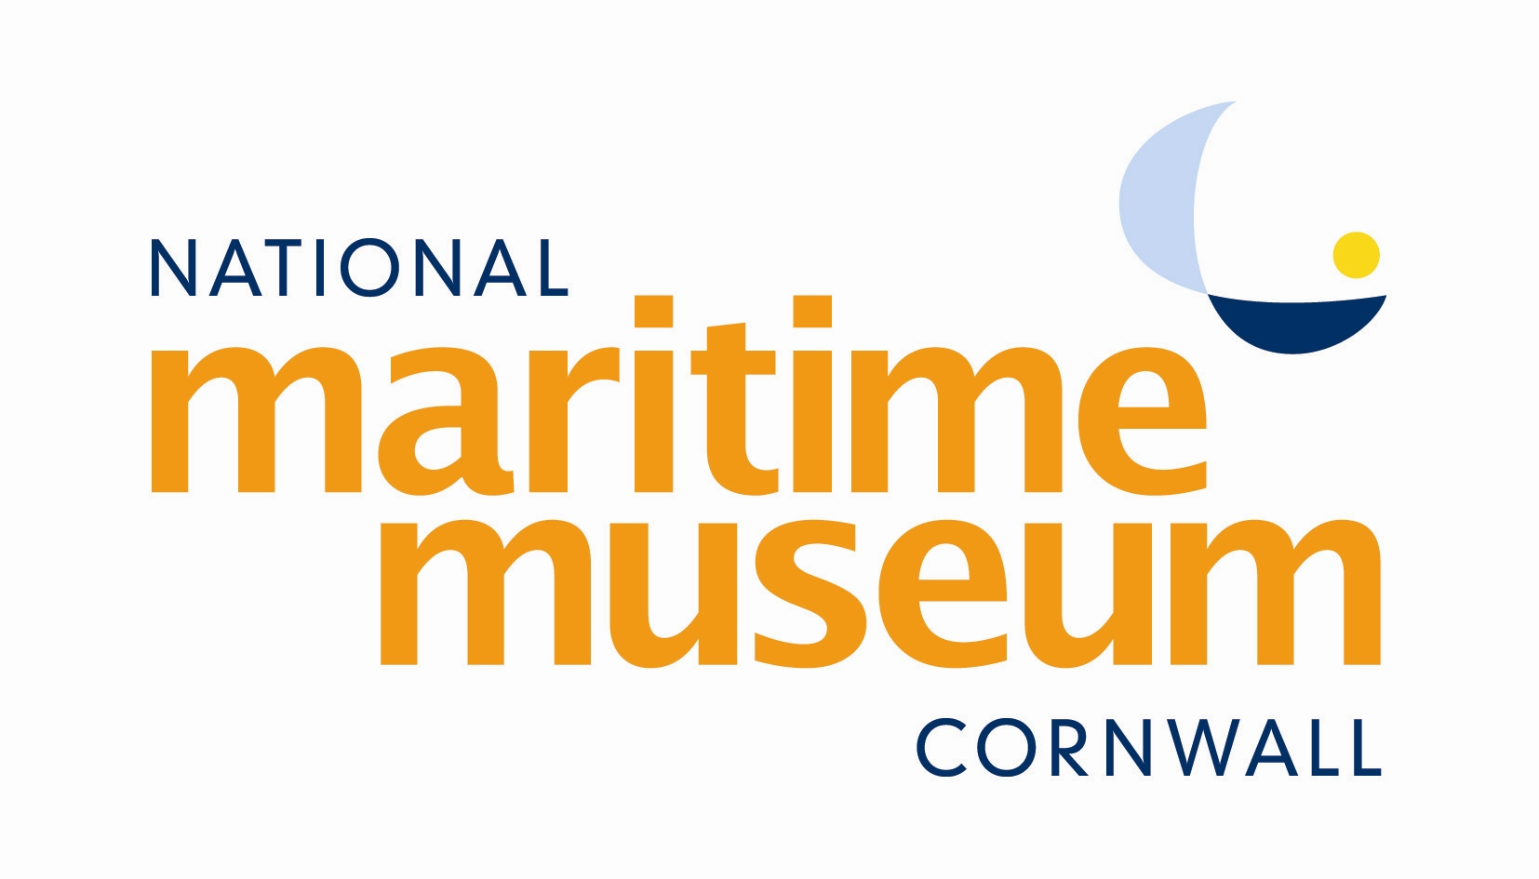

EQUAL OPPORTUNITIES MONITORING FORM
The National Maritime Museum Cornwall is committed to providing equality and diversity in all areas of its operation and in particular in the employment of staff, in the recruitment of volunteers and in its attraction of, and interaction with, visitors. We are committed to creating a culture where individual differences are valued and respected.

To help us monitor the effectiveness of our Equality and Diversity Policy, we would be grateful if you could complete this form and return it with your application.

This information will be separated from your application as soon as it is received. It will not be used in any part of the recruitment or appointment procedures.

Post applied for: ___________________________________________________________

Age
Under 16
16 – 25
26 – 35
36 – 45
46 – 55
56 – 65
65+
Prefer not to say

Gender
Female
Male
Prefer not to say

Do you consider yourself to have a disability?
Yes – please specify below
No
Prefer not to say

Ethnic Group
White British
White Other – please specify
Cornish
Gypsy/Traveller
Black British
Black African
Black Caribbean
Black Other – please specify
Chinese
Asian British
Asian Bangladeshi
Asian Indian
Asian Pakistani
Asian Other – please specify
Mixed Race – please specify
Prefer not to say

