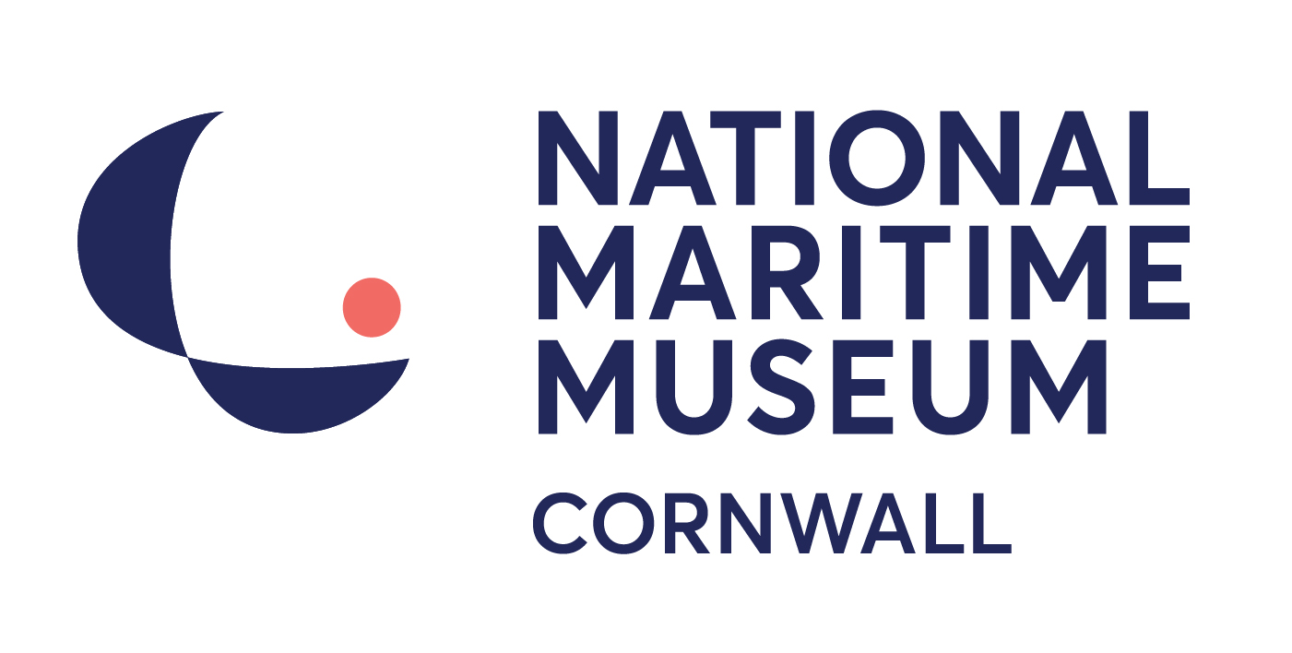

Volunteer Registration Form
Thank you for your interest in wishing to volunteer for us. Please tell us about yourself by completing this form.

We can then add your contact details to our database, and inform you of new opportunities when they become available. Our current volunteering opportunities can be found on our website, www.nmmc.co.uk.

Please complete all sections of this form with as much detail as possible and return to: Linda Frost, Human Resources Manager, National Maritime Museum Cornwall, Discovery Quay, Falmouth, Cornwall, TR11 3QY or via email to: lindafrost@nmmc.co.uk.

Please do not hesitate to call Linda on her direct line, 01326 214559, if you have any queries or require further information on volunteering.

Any information contained in this form will be treated as confidential.

Contact Details
Title:

First Name:

Surname:

Home Address (please include postcode):

Home Telephone Number:

Mobile Telephone Number:

Email:

Are you applying for a particular role?
Where did you see the role advertised?

Your expectations
Please tell us why you are interested in volunteering for us? For example, to gain some work experience in a specific area, to gain skills and confidence before applying for work, to meet new people, etc.

Your current or previous work experience
Please tell us about your current or previous work experience. We ask for this information to give us a better idea of your skills and experience.

Your training and qualifications
What training and/or qualifications do you have which you feel may be relevant? This will help us match you to the most appropriate volunteer opportunities, so please include any technical skills you have.

Previous volunteering experience
Please tell us about previous volunteering experience you have had. What did you enjoy the most about your previous volunteering experience? Have you volunteered with us before?

Skills, interests and hobbies
Tell us about your skills and hobbies. Are there any languages you speak? Do you enjoy photography, sewing, boat maintenance, DIY, research?
Please include anything that we might be able to call on you to help us with, no matter how strange it might seem now!

Which areas would you be interested in volunteering in?
Please tick all those that you would be interested in volunteering in. Please note when we meet to discuss our current volunteer opportunities, we can talk about the different roles in more detail.
Administration Assistant
Boat Collection (Workshop)
Front of House Assistant
Gallery Assistant
Learning Assistant
Learning Activities Assistant
Library
Marketing Assistant
Short-term/special Projects*

*We are keen to develop volunteers and try to create roles which support projects and departments for a specified period of time or task.

Availability
Please note that this information is a guide only; it does not commit you in any way, but to assist us in matching your availability with a volunteering opportunity.
My preferred day(s) would be: (please tick)
 | Morning | Afternoon | All day
Monday
Tuesday
Wednesday
Thursday
Friday
Saturday
Sunday

Would you be available at short-notice? YES / NO
Are there any times of the year when you know you would not be available, e.g. school holidays:

Access and support requirements
This will not affect your application and will only be used to help us to support your volunteering.

Are there any particular adaptations or access arrangements, which would assist you? (Large print, wheelchair access, etc.)

Training
All volunteers will be expected to undertake general induction training, which lasts a morning. You will also receive specific department training in order for you to be confident in your role. For example, you might be ‘buddied’ with an experienced volunteer for your first few shifts, shadow or oversee activities. We also encourage volunteers to attend any training sessions relevant to their role and department meetings.

Administration
All volunteers will come into contact with the public at some point and, as we have a duty of care to children and other vulnerable people, we ask all our volunteers to provide two references to support your application. We are unable to accept relatives as referees, but previous employers, people you have volunteered for in the past, or anyone you have a professional relationship with will be fine. One of your references can be a friend, neighbour or fellow volunteer. Contact information for your referees will be requested at the time of your induction training.

For roles which support our Education team we will require the volunteer to agree to a check by the Disclosure and Barring Scheme. The cost will be covered by the Museum.

I have read and understood all the above and I confirm that the information that I have provided is correct.

Signed

Date

Parental/Guardian Consent (if necessary)

We will require parental or guardian consent for any volunteer aged sixteen or seventeen. If you are within this age range, please ensure that your parent or guardian reviews this form, and gives consent for you to volunteer with us.

For the Parent or Guardian: The Museum has extensive Health and Safety policy and procedures to keep its volunteers safe. Emergency contact details will be taken if the volunteer’s application is successful. By completing your name in the following box, you are agreeing to allow emergency medical treatment, if necessary:

Signature of Parent/ Guardian

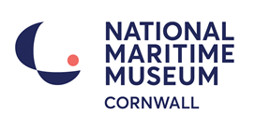

EQUAL OPPORTUNITIES MONITORING FORM (V)
The National Maritime Museum Cornwall is committed to providing equality and diversity in all areas of its operation and in particular in the employment of staff, in the recruitment of volunteers and in its attraction of, and interaction with, visitors. We are committed to creating a culture where individual differences are valued and respected.

To help us monitor the effectiveness of our Equality and Diversity Policy, we would be grateful if you could complete this form and return it with your volunteer registration form.

The data collected will only be used for statistical and monitoring purposes to assist the National Maritime Museum Cornwall in meeting statutory and other obligations.

Gender
Female
Male
Prefer not to say
Age
Under 16
16 – 25
26 – 35
36 – 45
46 – 55
56 – 65
65+
Prefer not to say

Do you consider yourself to have a disability?
Yes – please specify below
No
Prefer not to say

Ethnic Group
White British
White Other – please specify
Cornish
Gypsy/Traveller
Black British
Black African
Black Caribbean
Black Other – please specify
Chinese
Asian British
Asian Bangladeshi
Asian Indian
Asian Pakistani
Asian Other – please specify
Mixed Race – please specify
Prefer not to say

