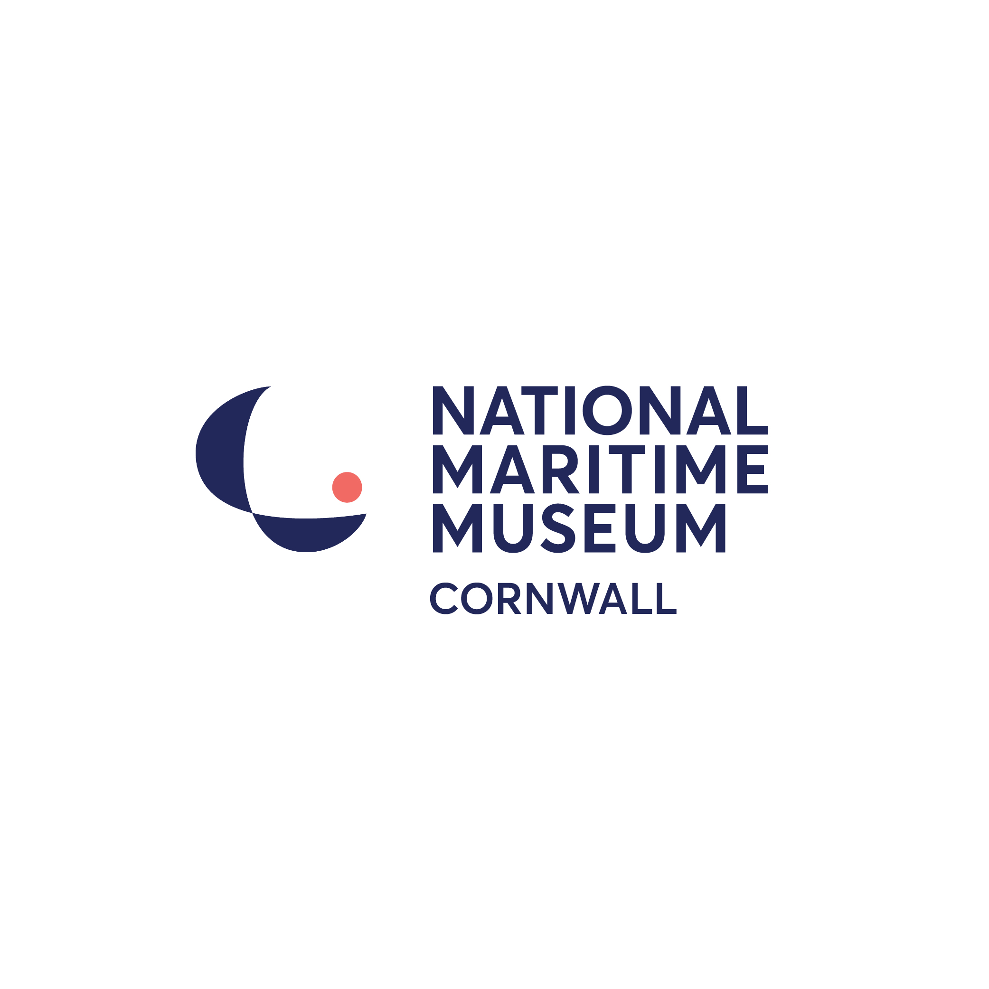

STAFF Application Form

All information supplied on this form will be treated as STRICTLY CONFIDENTIAL

Position applied for:

1. Personal details:

Title

Surname

First name(s)
Permanent address including postcode:

Telephone numbers: | Home: |  | Work:
 | Mobile:
Email Address:
Are we able to contact you at work? |  | By Phone: Yes / No |  |  | By Email: Yes / No
Do you hold a current full car driving licence? |  |  |  | Yes / No
Do you require a work permit? |  |  |  | Yes / No
Will this be your only employment? |  |  |  | Yes / No

2. Education and training:

School/College/University | Qualification/Training | Grade/Results

3. Further education, training and development:
(For example short courses, first aid, computer skills, work-based NVQ and any current courses)

Dates | Details of training

4. Professional qualifications, Membership of Professional Bodies:

Dates | Full details of professional qualifications, include level of membership, date achieved

5. Present/most recent employment details:

Employer’s name and address |  | Job title
Employer’s name and address |  | Date appointed
Employer’s name and address |  | Leaving date
Employer’s name and address |  | Latest/final salary
Employer’s name and address |  | Length of notice
Summary of main duties and responsibilities

Reason for leaving

6. Previous employment:
Most recent employer first, please include any unpaid or voluntary work

From | To | Employer, position held, brief outline of duties | Reason for leaving
Please give details and an explanation for any gaps in your employment history

7. Reasons for applying for this post/personal statement:

Please summarise why you feel you are suitable for this position. Reference should be made to the job description and your previous experience, personal achievements and any other relevant information

8. Additional information

How many hours are you looking to work?  (Please circle) | Up to 8 hrs | 8-16 hours | 16-25 hours | 25+ hours

When are you available to work?
 | Monday | Tuesday | Wednesday | Thursday | Friday | Saturday | Sunday
From
To

9. Hobbies and outside interests:

10. How did you learn about this vacancy?

11. Convictions/Cautions

The amendments to the Exceptions Order 1975 (2013) provide that certain spent convictions and cautions are ‘protected’ and are not subject to disclosure to employers and cannot be taken into account. Guidance and criteria on the filtering of these cautions can be found on the Disclosure and Barring Service website.

Do you have any convictions, cautions, reprimands or final warnings that are not ‘protected’ as defined by the Rehabilitation of Offenders Act 1974 (Exceptions Order 1975), as amended 2013?

Please circle: Yes / No

Are you facing any criminal prosecutions? Yes / No

If yes, please give details:

12. References:

Please give details of two referees, one of whom should be your present or last employer. If you do not wish us to approach either of your referees without your permission place a cross in the box provided. Referees should not be related to you.

a) Present / most recent employer |  | b) Second referee
Name and  address |  | Name and  address
Job Title |  | Job Title
Email |  | Email

I do not wish my referee to be approached without my permission:

Reference a) Reference b)

13. Equality Act 2010

This Act protects people with disabilities from unlawful discrimination. If we know you have a disability and you are selected for the position, we will make adjustments to the working arrangements or the working environment if it is reasonable in the circumstances to do so.

Do you consider that you have a disability? Yes / No

Please let us know if you believe there are any reasonable adjustments that would enable you to undertake the position, by attaching a separate sheet to this application with such details.

Equal Opportunities

The National Maritime Museum Cornwall is an Equal Opportunities employer and is committed to creating a culture where individual differences are valued and respected.

General Data Protection Regulations

The information you supply on this application form will only be used to assess your suitability for the post applied for (or another relevant post). Your details will only be disclosed to those persons involved in the selection process or for Human Resources administration.

National Maritime Museum Cornwall will retain the forms of unsuccessful applicants for 12 months, in accordance with current guidance.

Please be assured that the National Maritime Museum Cornwall will protect your information and treat it as confidential at all times.

Full details of how the Museum collects and processes personal data relating to job applicants is outlined in our Job Applicant Privacy Notice, which can be downloaded from our website.

Declaration

I declare that to the best of my knowledge and belief, all the statements and information given in this form are true and complete and that I have not withheld any material fact. I understand that if I am appointed and any of the information I have provided is inaccurate, I could be liable to dismissal.

I consent to the National Maritime Museum Cornwall processing my Application Form in accordance with the General Data Protection Regulations (2018) and the Job Applicant Privacy Notice.

I consent to National Maritime Museum Cornwall obtaining information or references from any present or previous employers, or any other company or institution which National Maritime Museum Cornwall considers appropriate, with prior permission.

Signature _________________________________________

Date _____________________________________________

Submitting your application

Email your completed application form, to Linda Frost, Head of Human Resources: lindafrost@nmmc.co.uk

Or post/hand your application to:
Linda Frost
Head of Human Resources
National Maritime Museum Cornwall
Discovery Quay
Falmouth
Cornwall
TR11 3QY

EQUAL OPPORTUNITIES MONITORING FORM
The National Maritime Museum Cornwall is committed to providing equality and diversity in all areas of its operation and in particular in the employment of staff, in the recruitment of volunteers and in its attraction of, and interaction with, visitors. We are committed to creating a culture where individual differences are valued and respected.

To help us monitor the effectiveness of our Equality and Diversity Policy, we would be grateful if you could complete this form and return it with your application.

This information will be separated from your application as soon as it is received. It will not be used in any part of the recruitment or appointment procedures.

Post applied for: ___________________________________________________________

Do you consider yourself to have a

disability?
Yes – please specify

No
Prefer not to say

Ethnic Group
White British
White Other – please specify

Cornish
Gypsy/Traveller
Black British
Black African
Black Caribbean
Black Other – please specify

Chinese
Asian British
Asian Bangladeshi
Asian Indian
Asian Pakistani
Asian Other – please specify

Mixed Race – please specify

Prefer not to say

Age
Under 16
16 – 25
26 – 35
36 – 45
46 – 55
56 – 65
65+
Prefer not to say

Gender
Female
Male
Transgender
Prefer not to say

